

* Stress is perceived by the body, as a threat and therefore the body reacts by amping up the protective capabilities
  + The hypothalamus signals the adrenal glands to release the hormones of adrenaline and cortisol
  + Adrenaline increases the heart rate, elevates BP and boosts the supply of energy
  + Cortisol increases glucose in the blood stream, increases the use of glucose by the brain and increases our body’s ability to repair tissues
* “Fight-or-Flight” response is normally self-limiting, however if there is an ever present stressor it is always on
  + Long term effects of overexposure put a person at risk for: anxiety, depression, digestive problems, heart disease, sleep problems, weight gain and memory difficulties

Stress Management:

* Eating a healthy diet, regular exercise and plenty of sleep
* Practicing relaxation techniques or learning to meditate
* Fostering healthy friendships
* Having a sense of humor
* Seeking professional counseling when needed

RESOURCES:

American Psychological Association

National Institute of Health

PsychCentral

Mayo Clinic

“The greatest weapon against stress is our ability to choose one thought over another.”- William James

The Link between Poverty and Stress:

* Those in Poverty are more likely to develop diabetes, hypertension, depression, and anxiety
* Children of poverty suffer from difficulty with cognitive function and memory

Chronic Stress and The Body

* Based upon a study down on adult rats, chronic stress causes more myelin-producing cells and fewer neurons
  + This disrupts the normal balance in the brain and causes changes in the communication in the brain
* Patients with stress disorders, such as PTSD, have alterations in their brain connectivity leading to stronger connection between the hippocampus and the amygdala (which controls the fight or flight response
  + The imbalance leads to a stronger response to stress with limited ability to shut down the response
* Chronic Stress affects cognition function due to the change in myelin-producing cells rather than neurons, which causes for difficulty with learning and memory skills.



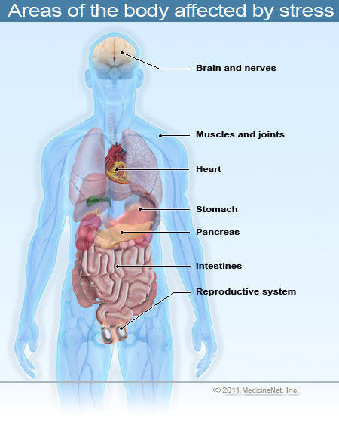

PLACE PHOTO HERE,

OTHERWISE DELETE BOX

Chronic Stress and The Brain

The Effects of Chronic Stress on Health